Event Announcement AAAnnouncemnt

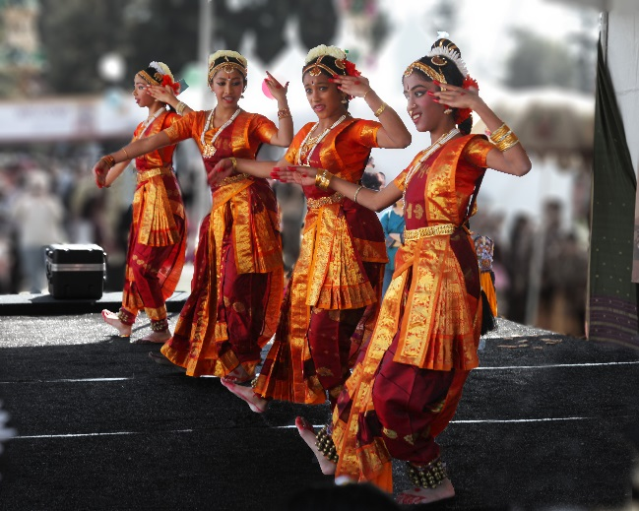
EVENT: DIWALI FAMILY FESTIVAL
ON VIEW: Sunday, October 26, 2014

October in India means time for Diwali--the Festival of Lights--and one of the largest celebrations in the nation. We will celebrate the holiday with traditional performances, music and dance with Arpana Dance Company and Rangoli Dance Company, hands-on art projects such as clay lamp making, miniature Indian paintings and Diwali cards, plus open galleries and an art scavenger hunt. Bring the family, bring friends or come by yourself--there is something for everyone at this FREE festival!
Made possible in part by the Ann Peppers Foundation, the Katharine Audrey Webb Foundation and the Nissan Foundation.

About USC Pacific Asia Museum
USC Pacific Asia Museum is the only museum dedicated to Pacific Asia at a major research university in the United States. The museum’s mission is to further intercultural understanding through the arts of Asia and the Pacific Islands. Since 1971, USC Pacific Asia Museum has served a broad audience of students, families, adults and scholars through its education and outreach programs.
46 North Los Robles Avenue, Pasadena, California 91101 626.449.2742 pacificasiamuseum.usc.edu

