Canva steps:
- Open the link sent in the email. It is also hyperlinked here.
- Create a FREE Canva account. This allows you access to edit and save these templates.
- Choose one or more templates to use.
- Upload an image of yourself, your organization, your lab, or anything that represents the work you do. This can be uploaded from your computer and dragged and dropped into the white box. If you don’t want to include an image, please delete the white box and text.
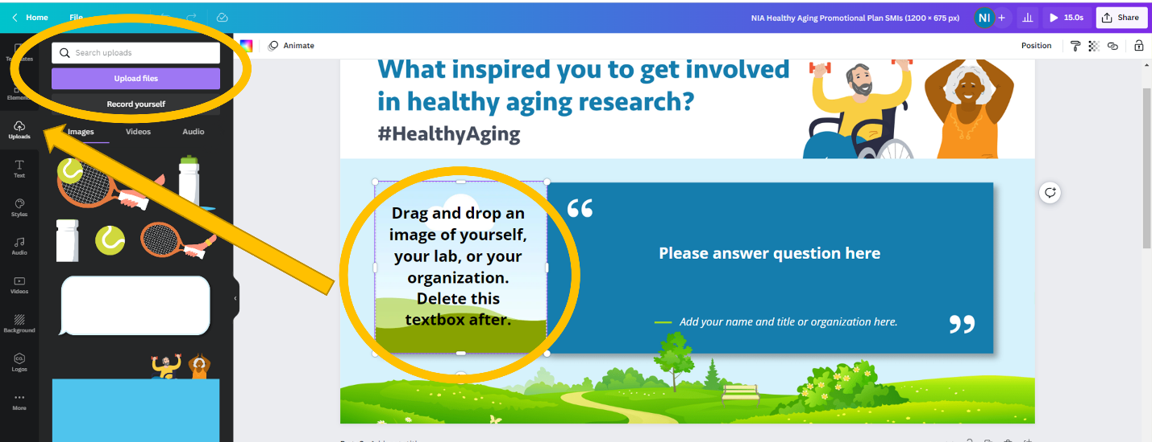
- Click the textboxes to add a quote. Prompts are already available in the template, but feel free to add any information you’d like to help answer the Twitter Chat questions. You can adjust the font, size, and colors at the top.
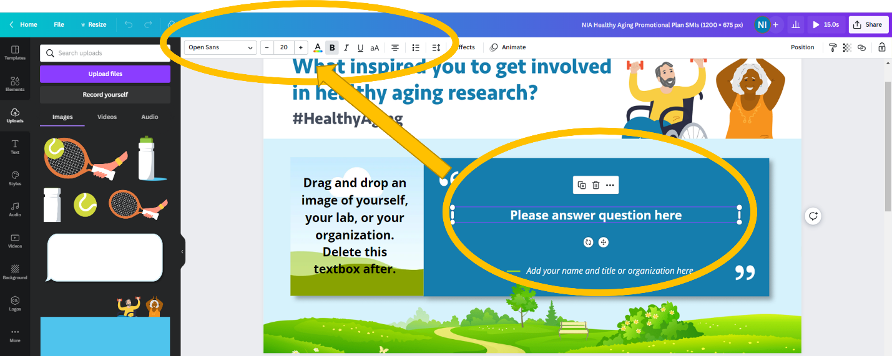
- Once you have finalized your graphic, click “share” in the top right corner. Download this as a jpeg or a png. If you only created one graphic you can select which ‘page’ to download in the download drop down.
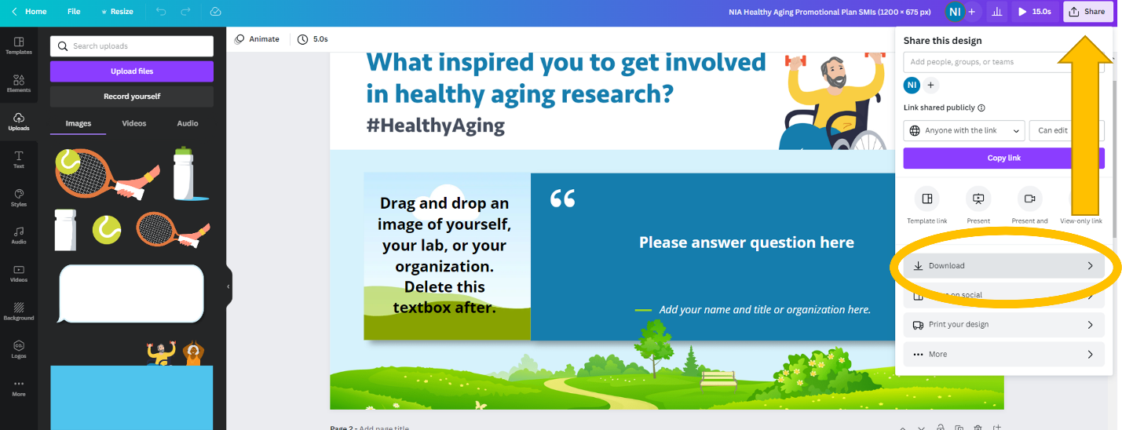
- Plan to share your graphics during September and tag @NIHAging and use the #HealthyAging hashtag so NIA can help amplify!

